**Software requirement specification**

**Home Application**

Prepared by TamNT

HCM 29/04/2022

History

|  |  |  |  |  |
| --- | --- | --- | --- | --- |
| Date | Version | Description | Written by | Mentor |
| 29/04/2022 | 1.0 | Final SRS | TamNT | ThanhPB |
| 26/02/2022 | 0.1 | SRS init | TamNT | ThanhPB |
|  |  |  |  |  |

Catalog

1. Introduction 2

2. Use Case Diagram 2

3. Specification requirement 2

**Home_SRS_01:** 2

**Home_SRS_02: 3**

**Home_SRS_03: 4**

**Home_SRS_04: 4**

**Home_SRS_05: 5**

**Home_SRS_06: 5**

**Home_SRS_07: 6**

# **Introduction**

* 1. **. Purpose**

The purpose of this document is to provide a full and accurate description of this software’s requirement. This document can be also be used to make input for design and testing purposes for Home Application

* 1. . **Project Scope**

This document is used to define requirement for FUNix’s Home Application

* 1. **. Audience**

FUNiX, Developer, Tester

* 1. **Glossary**

SRS: Software Requirement Specification

SW: Software

TBD: To be defined

# **Use Case Diagram**

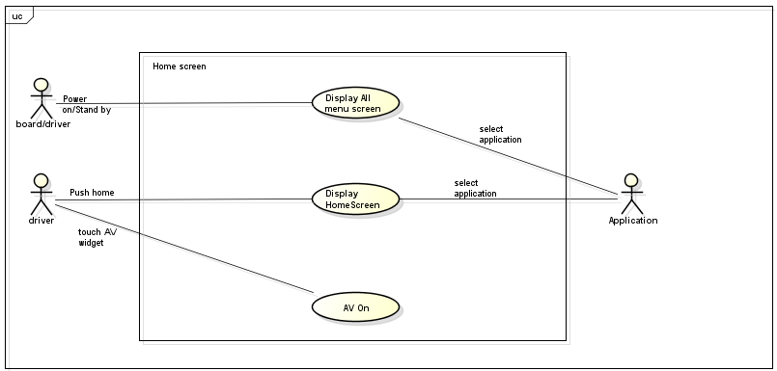

**Feature 1: Use Case Diagram for Home Application**

# **Specification requirement**

Home_SRS_01:

|  |  |
| --- | --- |
|  | **Description** |
| Purpose | Provide layout design for **Home Application** |
| Actor / Event | User |
| Requirement | **Functional Requirement:**  **Home_SRS_01.1.** Home’s start up screen is divided into 3 separated areas.    **Home_SRS_01.2:** Status Bar Area. Display status information, specially time and date of system  **Home_SRS_01.3:** Widgets Area. Display information of AVN Application via widgets (media, climate, map, etc)  **Home_SRS_01.4:** Application Menu Area. Display application in Horizontal Listview format  More information can be found in UI Sample.pdf / UX Sample.pdf |

Home_SRS_02:

|  |  |
| --- | --- |
| **Term** | **Description** |
| Purpose | Describe on-screen interaction |
| Actor / Event | User |
| Requirement | **Functional Requirement:**  **Home_SRS_02.1:** All application in system can be stored in xml file.  **Home_SRS_02.2:** Display list is scrollable when there are more than 6 applications.  **Home_SRS_02.3:** Scroll Bar only shown when there are more than 6 application.  **Home_SRS_02.4:** Application display in list with icon, title.  **Home_SRS_02.5:** All application must be displayed when Home Application is started.  **Home_SRS_02.6:** Home screen can only display up to 6 application at a time.  **Home_SRS_02.7:** Only one item can be “Focus” on screen at a time.  **Home_SRS_02.8:** Application can be used when click on corresponding application.  **Home_SRS_02.9:** Each application must have 3 status: press, normal, focus.  **Home_SRS_02.10:** All app icon can be drag and change position  **Non-functional Requirement:**  **Home_SRS_02.11:** Application list must be displayed no more than 2 second after Home Application start up. |

Home_SRS_03:

|  |  |
| --- | --- |
| **Term** | **Description** |
| Purpose | Describe Status Bar Area requirement |
| Actor / Event | User |
| Requirement | **Functional Requirement:**  **Home_SRS_03.1:** Display Time and Date of system.  **Home_SRS_03.2:** BACK button show when screen is not main screen.  **Home_SRS_03.3:** Click BACK button to transition to main screen.  **Non-functional Requirement:**  **Home_SRS_03.4:** Status Bar must respond to change no more than 2 second after change has been made.  **Home_SRS_03.5:** Update system Time/Date every 1 minute. |

Home_SRS_04:

|  |  |
| --- | --- |
| **Term** | **Description** |
| Purpose | Describe Widget Area requirement |
| Actor / Event | User |
| Requirement | **Functional Requirement:**  **Home_SRS_04.1:** Always show 3 widgets: Map, Climate, Media  **Home_SRS_04.2:** Display Climate which get information from Climate Simulator app.  **Home_SRS_04.3:** Display song information when Media player is played.  **Home_SRS_04.4:** When Map application icon is touched, Map application must started.  **Home_SRS_04.5:** When Climate application icon is touched, Climate application must started.  **Home_SRS_04.6:** When Media application is touched , Media application must started.  **Home_SRS_04.7:** Information in each widget update in real time, when data of widget changes. |

Home_SRS_05:

|  |  |
| --- | --- |
| **Term** | **Description** |
| Purpose | Describe Map widget |
| Actor / Event | User |
| Requirement | **Functional Requirement:**  **Home_SRS_05.1:** Always display current position of the vehicle. |

Home_SRS_06:

|  |  |
| --- | --- |
| **Term** | **Description** |
| Purpose | Describe Climate widget |
| Actor / Event | User |
| Requirement | **Functional Requirement:**  **Home_SRS_06.1:** Display the vehicle's air conditioning  parameters.  **Home_SRS_06.2:** Display title of Climate widget.  **Home_SRS_06.3:** Display text of driver and text of passenger.  **Home_SRS_06.4:** Displays the wind direction of driver and  passenger.  **Home_SRS_06.5:** Display temperature of driver, If the temperature is lower 16.5°C, the screen will show text “LOW”, if it is higher 31.5 °C, the screen will show text “HIGH”.  **Home_SRS_06.6:** Display icon fan and level fan. Level fan can be  changed.  **Home_SRS_06.7:** Display outside temperature.  **Home_SRS_06.8:** Display mode auto on or auto off. AUTO on: set  temperature and wind direction to auto.  **Home_SRS_06.9:** Display mode sync on or sync off. SYNC on: Driver and Passenger will show same mode, temperature follow  driver  **Non - Functional Requirement:**  **Home_SRS_06.10:** Information of Climate Widget update real  time. |

Home_SRS_07:

|  |  |
| --- | --- |
| **Term** | **Description** |
| Purpose | Describe Media widget |
| Actor / Event | User |
| Requirement | **Functional Requirement:**  **Home_SRS_07.1:** Always display song name, author and song image.    **Home_SRS_07.2:** Song name, author, image change when song is change  **Non-functional Requirement:**  **Home_SRS_07.3:** Media widget must responded with no more than 1s delay |